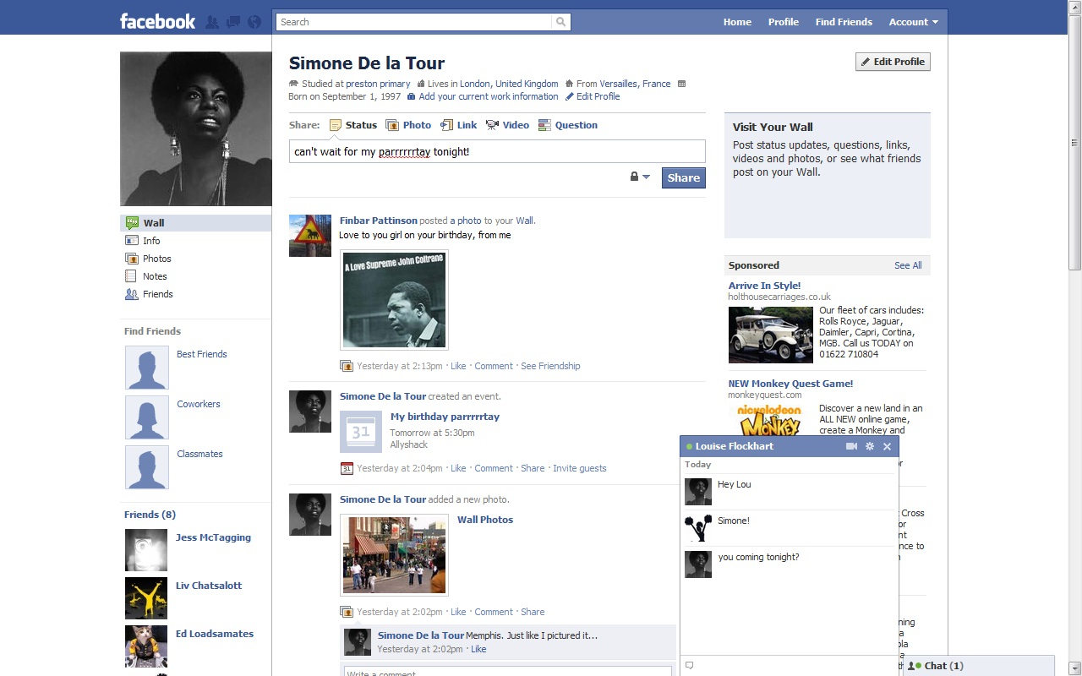
Beginners Guide to Facebook
Personal Info- this is what everyone sees
Profile image- this is the image everyone sees.
Friends – number in brackets is the number of people you are ‘Friends’ with. They are shown below
Status- This is where you post to your friends (or everyone else, depending on settings), what you are up to.
Photos- click here to all photos you have uploaded
Private Message- this is where you can privately chat with someone
Friends Status- This is where both your own and your friends posts’ appear
Account settings- Click here to adjust security settings

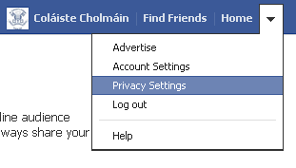
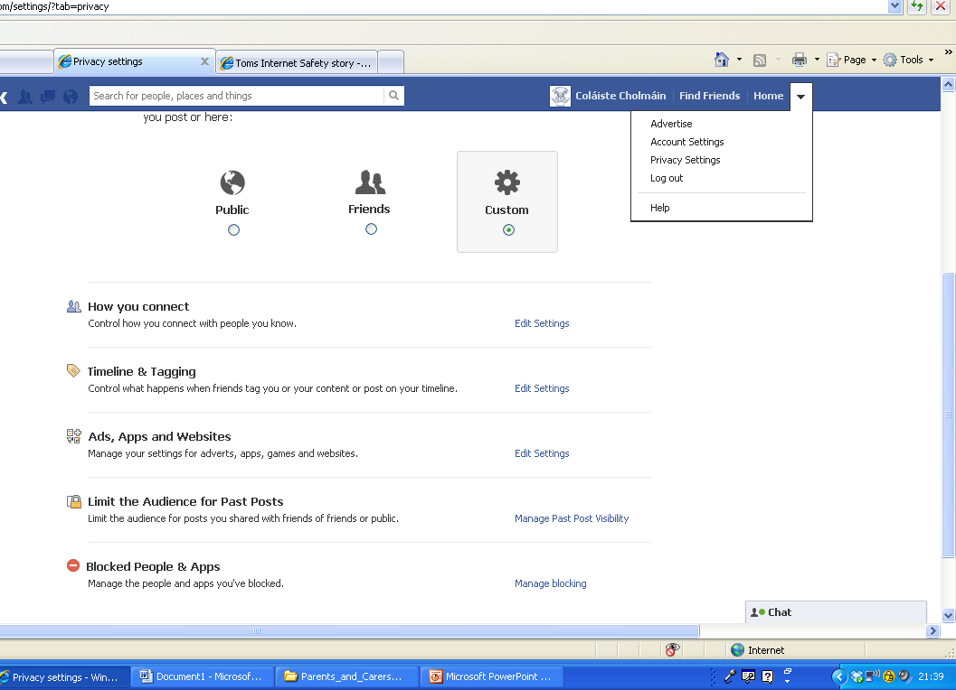

Click on the drop-down arrow beside Home and select ‘Privacy Settings.

This will open a page with a range of options. You should go into each one and alter the settings accordingly.
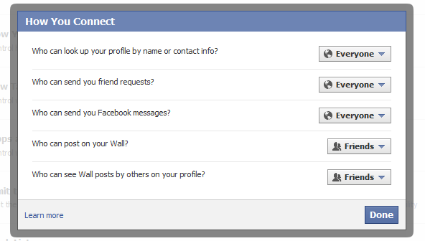

The top one – ‘How you Connect’ is probably most important.

