**How to create a your online account**

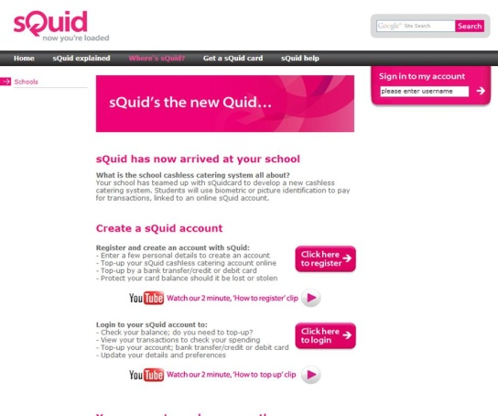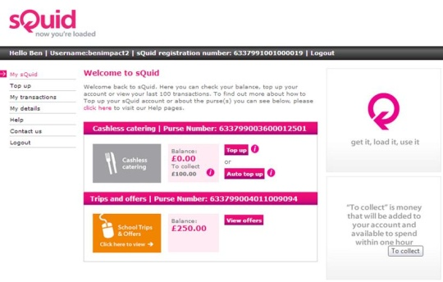

Your ‘**My sQuid’** screen will display the services available to you. You will see two ‘purse’ icons displayed:

‘Catering’ purse which allows you to add funds to your child’s in-school catering account for them to use on a daily basis.

‘Offers’ purse where you can view other items the school have made available for sale, which you may then purchase

**04**

**Your ‘My sQuid’ Summary Screen**

Having created an account you will be prompted to register your unique sQuid registration number, linking it to your sQuid account. This is the 16 digit number and 3 digit security code provided on your letter.

**Your sQuid registration number**

**03**

Firstly you need to create an account with sQuid. You will need to give your personal details, create a Username and Password and your own personal Security question and Answer. You will be sent an email to your given email address confirming all of these details except for your password, which is known only to you.

**Create a sQuid account**

**02**

Go to **squidcard.com/smartid** and click on the ‘**Click here to register**’ link. You will then be re-directed through to the sQuid portal where you can register and logon to your account.

**Register with sQuid**

**01**