ST. COLMAN’S COLLEGE
VIOLET HILL
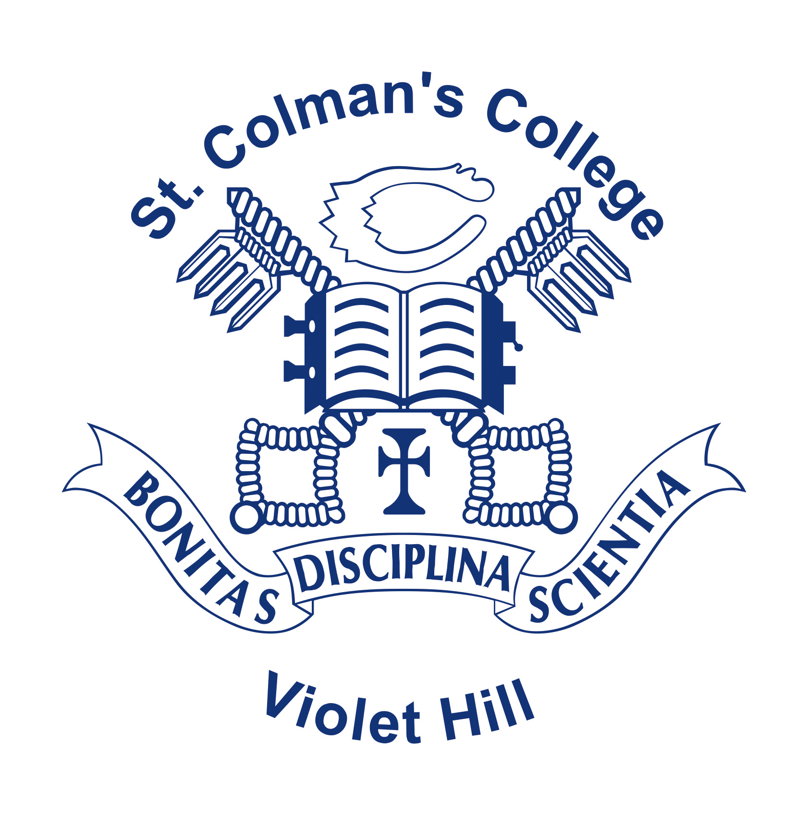

Careers & Education for Employability (EfE) Policy

Last Reviewed: June 2018
Reviewed by: C. O’HARE
Next Review: Sept 2019

Preamble

The Careers Department of St Colman’s College endeavours to meet the needs of all its students in preparing for third level education and the world of work in accordance with the College’s Mission statement of ‘Preparation for Life’ and ‘Pursuing Excellence.’

Additionally this policy gives clear cognisance to the recently published ETI/DEL Careers Strategy ‘Preparing for Success’ and the associated quality indicators.

The 6 core aims of this Policy for CEIAG are:

- Self Awareness & Development

- Careers Exploration

- Career Management

- Education for Employability

- Industrial/Business Links

- Entrepreneurship

- St Colman’s Careers Strategy

This strategy has devolved from the three particular documents (i) ETI/DEL Careers strategy ‘Preparing for Success’ (2015-20) and accompanying Quality Indicators (ii) St Colman’s College, School Development Plan 2018-2021 – Strand GEIAG ‘Careers Education Information, Advice and Guidance. (iii) St Colman’s College, Pastoral Care Policy.

The Careers department is seen as a vital constituent of the school curriculum which is maintained through strategic collaboration with Universities, Colleges, Practitioners, Sector Skills Councils (SSC) the ALC Community Co-ordinator, ELB’s, ESA, DE & DEL.

‘Careers sits at the heart of the Curriculum’ Preparing for Success- NI Careers Strategy. Increasingly Careers and CEIAG have moved to the core of the curriculum informing and directing the curriculum and curriculum leaders. The CEIAG Programme is centred upon the Learning Guidance Offer implemented through this joint strategy document by DEL and DENI: Preparing for Success: A guide to Developing Effective Decision Makers .

2. Departments
The Careers Department believes all teachers to be ‘teachers of careers’ it also recognises the influence subject teachers can have on a student career choice and for this reason it seeks integration with subject departments and areas of the curriculum through constantly seeking opportunities to keep all staff abreast of career developments and the most up to date information available. It also encourages communication and dialogue on career issues between departments and within the careers department. Departments are kept up to date through face to face meetings, department meetings, INSET, whole staff training and the departmental area of College website. Subject teachers are also encouraged by the H.o.D to seek advice both informally and formally.

3. Parents
Parents are key stakeholders in their son’s education and for this reason the careers department continues to work in partnership with parents in their son’s career decisions. Open communication, partnership and positive relationships with parents are vital in keeping parents fully informed at each stage of their son’s career progression, in particular Years 10/12/14. In particular the Careers Department organises an annual Subject Choice event for students in transition Yr 10, 12 & 13 including a UCAS information evening for Yr 14 students and their parents. The department also seeks to develop links with parents through the annual report to parents, press releases and the wider community programmes.

4. ICT
The Careers department seeks to utilise all aspects of ICT as a means of transmitting careers information. Students are also encouraged to engage with online learning resources such the College Virtual Learning Environment (VLE). The Department aims to keep pace with developing ICT resources and online learning. Additionally Year 14 University/College applications are made online, correspondence and communication with universities is completed electronically via email. More recently in 2013/14 the Careers Department has promoted the use of Podcast, Apps and social media (Twitter - @stcolmanscareers) as a means for delivering Careers and Employability Information to the students.

5. Resources – G12 (Careers Room)
The Careers Department has a specially designed, fully equipped careers library which has been established for the use of the students. The Library contains prospectuses for all Universities and Colleges in the UK and the Republic of Ireland, journals, careers magazines, newsletters and Labour Market bulletins. Additionally, it has ICT facilities, study tables and a soft seating area where students are encouraged to carry out their own personal research.

6. Pupil Guidance

Students in all year groups receive guidance either as a group or individually.

6.1 Year 10 – Careersserviceni - Mr Francis Gallagher re: Subject Choices and future career pathways.

6.2 Year 12 – Careerserviceni - Mr Francis Gallagher re: Subject Choice for AS/A2 Level and Career pathways.

6.3 Year 14 – Individual guidance from H.o.D Careers and/or DEL Careers Advisors. Students may also seek additional guidance based on the self referral system with the H.o.D re: University/College applications.

7. Industrial Visits

In conjunction with the College School Development Plan (2018-2021) ‘Work related learning’ the careers department and subject departments have established and developed industrial links for students in Yrs. 8 - 12. Additionally, Yr 13 students participate in a week long Work Shadowing Programme. Industrial links give students the opportunity to observe first hand a career/job in a particular industry but also allows students to recognise the link between the subjects they are studying and a particular career thus aiding motivation and ambition.

7.1 Business Links

Business Links is a key priority within the Community strand of the SDP. The Careers Department has developed substantial links with local, national and multinational businesses. The department aims to further develop and extend these links as means of extending Work –Related Learning.

7.2 Entrepreneurship/Self Employment

In keeping with the Education for Employability theme of the Revised Northern Ireland curriculum (2007) the Careers Department seeks to promote the concept of entrepreneurship within the student body in order to give students the knowledge and experience needed to recognise entrepreneurship and the spirit of business as a vital career option particularly after completing further qualifications. Additionally, it seeks to make connections and links with local entrepreneurs and past pupils who have established their own business both locally and internationally.

8. External Agencies

The Department continues to work in partnership with external support agencies such as ‘Charter’ Work Experience, Careers Service NI, ELB’s, ESA and DE/DEL etc and recognise the role statutory and non statutory agencies play in the career development of the students.

9. Work Shadowing

The Careers department recognises work experience as a vital component in the Careers programme. Each year students in Yr 13 participate in the College work experience programme. The aim of the careers department is to encourage students to attain meaningful and suitable work experience from which they can receive the best possible experience. The careers department also liaises with ‘Charter’ Work Experience to find specific work place in areas such as Medicine, Dentistry and Veterinary Science.

10. Staff Development
The Careers Department is fully committed to the professional development of all staff and departmental members. Departmental members are encouraged to develop in their professional practice through various means such as external courses, INSET, departmental meetings sharing best practice etc. The H.o.D will also seek opportunities to promote professional development for staff members and individuals in other departments to promote knowledge, skills and expertise in the areas of careers and Education for Employability.

11. Special Educational Needs
The Careers Department adheres strictly to the Equal Opportunities Policy of the College and believes that all students should have access to the same impartial information and advice on which to make an informed choice.The needs of students can vary and for this reason it continues to work very closely with the designated teacher Mr M. Doyle (V.P Pastoral) and the SENCO Co-ordinator. Each year a meeting is convened to discuss students who are about to enter Year 10/12/14 to organise Special Needs Transition Meetings with the student, parents, H.o.D Careers, SENCO and Mr Francis Gallagher from the Careersserviceni to discuss impending subject choices, university applications or preparation for the world of work. Parents may also request to meeting or seek support at various times throughout the year which the careers department will organise. Additionally the H.o.D Careers liaises and works closely with the Gifted and Talented Co-ordinator to ensure the needs and aspirations of students are fully met e.g Oxford & Cambridge Applications and visits.

11. Review and Evaluation
As a self improving, self evaluating school, the careers department will review, monitor and evaluate this policy in each of these areas on a regular and ongoing basis (annually).

