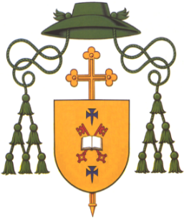
DIOCESE OF DROMORE
Most Rev Eamon Martin DD
Apostolic Administrator
Bishop’s House
44 Armagh Road
Newry
Co. Down BT35 6PN

Tel: (028) 3026 2444

E-mail: bishop@dromorediocese.org

5th May 2020

Dear A-Level students,

I want to let you know that you are especially in my thoughts and prayers at this difficult time.

In recent weeks I have received letters and emails asking me to remember you in my Masses and rosaries. I know that, for many of you, the uncertainty of this year has been hard to cope with.

The Covid-19 emergency has turned our world upside down and everywhere it has brought feelings of isolation, anxiety and helplessness. It has interrupted so many plans - for weddings, First Communions and Confirmations, travel and holidays. For you, it has gate-crashed what is such an important and special year in your lives, and it has left you wondering: what happens next?

At the same time the virus has not destroyed goodness and love. It has actually brought out the very best in so many people. I have seen first hand the amazing voluntary efforts that you and many others have been making to reach out to the elderly and marginalized, and to spread a message of hope for a better and brighter future.

And that is my message for you today: Hold on to Hope! As Pope Francis likes to put it: “Do not let yourselves be robbed of hope!”

One of my favourite lines in the Bible is “Every day, as long as this today lasts, keep encouraging one another” (Heb3:13). Thank you for keeping in touch with each other and for encouraging each other. Thank you to your teachers for being there for you online and for helping to keep your spirits up. Thank you to your parents and families and good friends who have been rallying around you and who will always be there for you - no matter what.

Some day you will look back on 2020 and tell your children and grandchildren about the way the coronavirus tried to spoil your dreams. I hope you will go on to describe how the opposite happened – it actually led to a strengthening of your character, your belief in yourself, your empathy for others, and your faith in God.

I promise to keep you in my prayers and I offer you my blessing and support for the days ahead.

Don’t forget - Hold on to hope!

God bless you.

Yours sincerely,
Most Rev Eamon Martin
Apostolic Administrator

