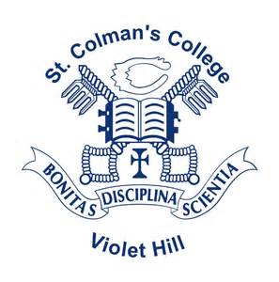

St.Colman’s College
46 Armagh Rd
Newry
BT35 6PP
Tel: 028 302 62451
e-mail: info@stcolmans.org.uk

Friday 25th June 2021

Pupil / Parent / Guardian
The school counselling service provided by Familyworks will continue to be available for all students from 28th June until 14th July and from 16th - 27th August 2021.
Pupils can self-refer via the digital referral form on the Familyworks website or via their telephone helpline numbers, which are 02891821721 and 02891820341.

Regards
Mr K Franklin

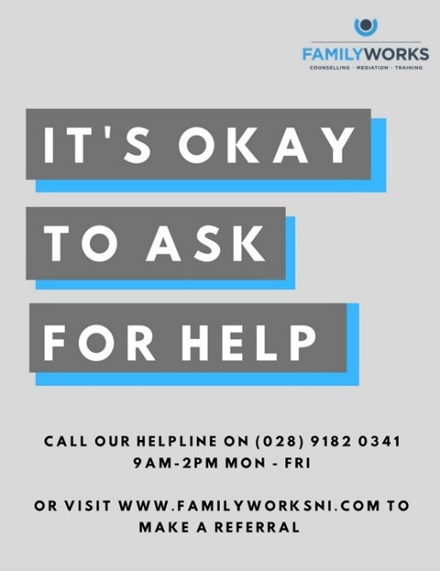
Vice Principal
Kfranklin940@c2kschools.net
