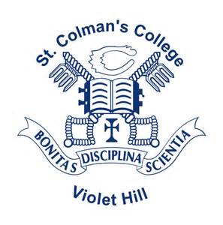

St.Colman’s College
46 Armagh Rd
Newry
BT35 6PP
Tel: 028 302 62451
e-mail: info@stcolmans.org.uk

Friday 18th June 2021

Parent / Guardian
Please note that, as per the school calendar, the last day of term for students is Friday 25th June. This is a half day for students and classes will finish at 1130am. While normal school transport will be provided in the morning it will not be available at 1130am. Parents / guardians are asked to ensure transport home for their sons.
Pupils may wear either their school uniform or St.Colman’s leisurewear to school next week.
There will be football blitzes on as follows:
- Wednesday 23rd June - J2 year group
- Thursday 24th June – J3 year group

Uniform Exchange
We would invite anyone who has items of school uniform that have little wear and tear to donate these to the school for the purposes of uniform exchange.
The extended period of remote learning has led to a scenario where pupils have outgrown uniforms that remain in a relatively new condition. We would welcome the following items:
- Blazers
- Shirts
- Trousers
- Jumpers
- ¼ zip PE tops
- PE jerseys
We would ask that these items are freshly laundered and stored on a hanger with sizes clearly labelled. These can be left in the school Reception at any time between 0900 and 1630 week beginning Mon 21st June. All sizes are welcome.
Alongside this I would encourage any parent / guardian who may wish to avail of these items to contact me directly either by email or phone. Given the current climate it may be prudent to pool resources and make good use of uniform items that may otherwise go to waste. Please do not hesitate to either donate or request items.

Regards
Mr K Franklin

Vice Principal
Kfranklin940@c2kschools.net

